Project Development Phase
Model Performance Test

Date | 12 January 2026
Team ID | LTVIP2026TMIDS75250
Project Name | Weather-Based Prediction of Wind Turbine Energy Output
Maximum Marks | 10 Marks

Model Performance Testing:
Project team shall fill the following information in model performance testing template.
S.No. | Parameter | Values | Screenshot
 | Metrics | Regression Model:  MAE – 120.32, RMSE – 255.3, R2 score - 0.958 | 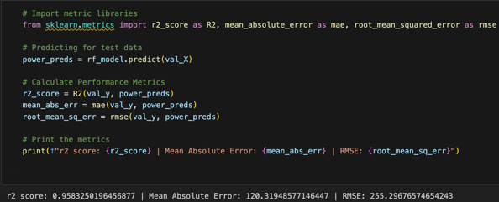
 | Tune the Model | Hyperparameter Tuning -  n_estimators=200  max_depth=6  min_samples_leaf=15  random_state=42 | 